Please following the following tutorial:

https://docs.docker.com/get-started/docker-concepts/the-basics/what-is-a-container/
https://docs.docker.com/get-started/docker-concepts/the-basics/what-is-an-image/
https://docs.docker.com/get-started/docker-concepts/the-basics/what-is-docker-compose/
https://docs.docker.com/get-started/docker-concepts/running-containers/publishing-ports/
https://docs.docker.com/get-started/docker-concepts/running-containers/overriding-container-defaults/
https://docs.docker.com/get-started/docker-concepts/running-containers/persisting-container-data/
https://docs.docker.com/get-started/docker-concepts/running-containers/sharing-local-files/
https://docs.docker.com/get-started/docker-concepts/running-containers/multi-container-applications/

Please write a document with screenshots and notes and commit it to your github repo.

Recommendations:
https://docs.docker.com/desktop/install/windows-install/
https://docs.docker.com/desktop/wsl/

Docker Lab 5 - Experiment Guide
Complete Step-by-Step Guide with Screenshot Requirements

Experiment 1: Basic Container Concepts

Step 1: Run First Container
docker run --rm hello-world

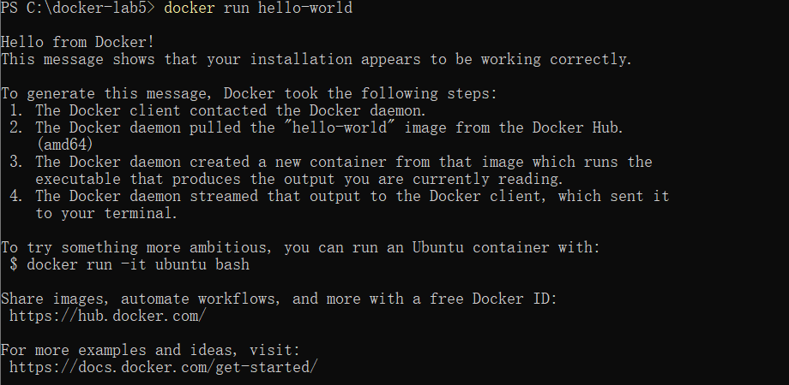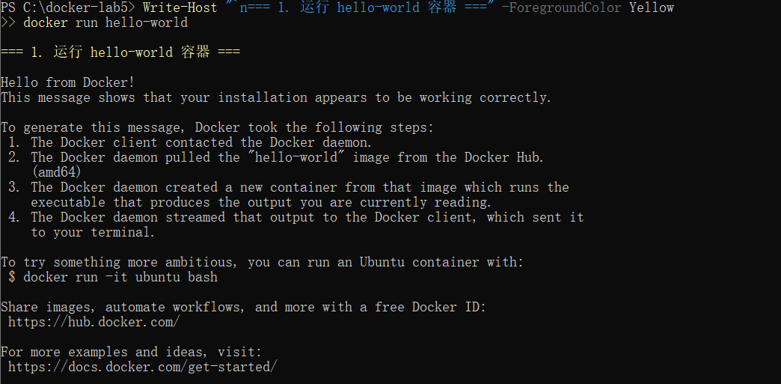Experiment 2: Multiple Containers and Isolation

Step 1: Run Different Linux Distributions
docker run -d --name ubuntu-container ubuntu sleep 3600
docker run -d --name alpine-container alpine sleep 3600
docker run -d --name centos-container centos:7 sleep 3600

Step 2: Check Container Status
docker ps --format "table {{.Names}}\t{{.Image}}\t{{.Status}}"

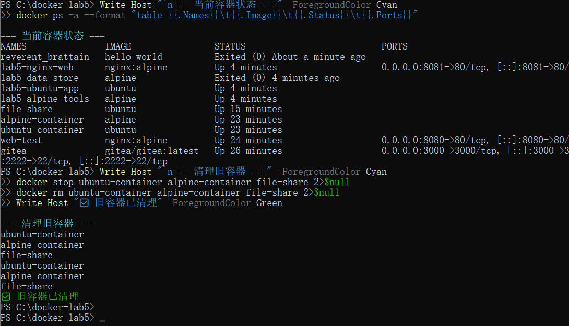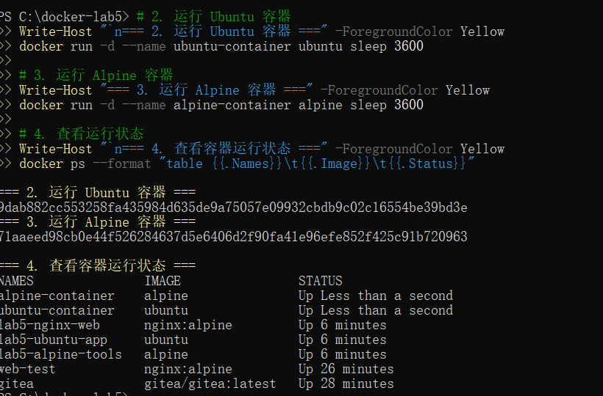Step 3: Verify Container Isolation
docker exec ubuntu-container sh -c "echo 'From Ubuntu' > /tmp/test.txt"
docker exec alpine-container sh -c "echo 'From Alpine' > /tmp/test.txt"
docker exec centos-container sh -c "echo 'From CentOS' > /tmp/test.txt"

docker exec ubuntu-container cat /tmp/test.txt
docker exec alpine-container cat /tmp/test.txt
docker exec centos-container cat /tmp/test.txt

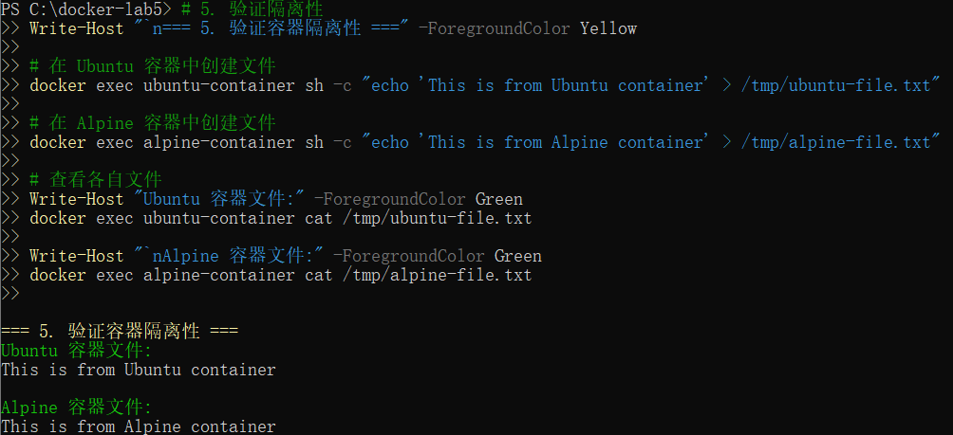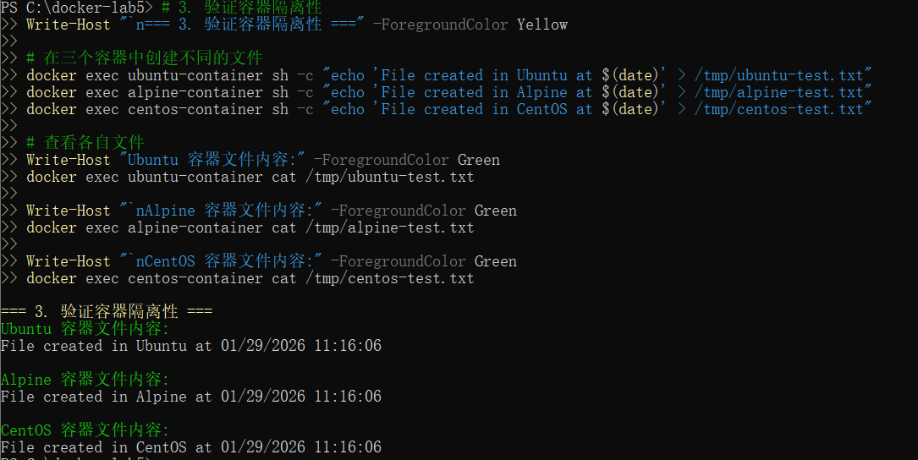Experiment 3: Port Publishing

Step 1: Run Nginx with Port Mapping
docker run -d --name nginx-test -p 8888:80 nginx:alpine

Step 2: Check Port Mapping
docker port nginx-test

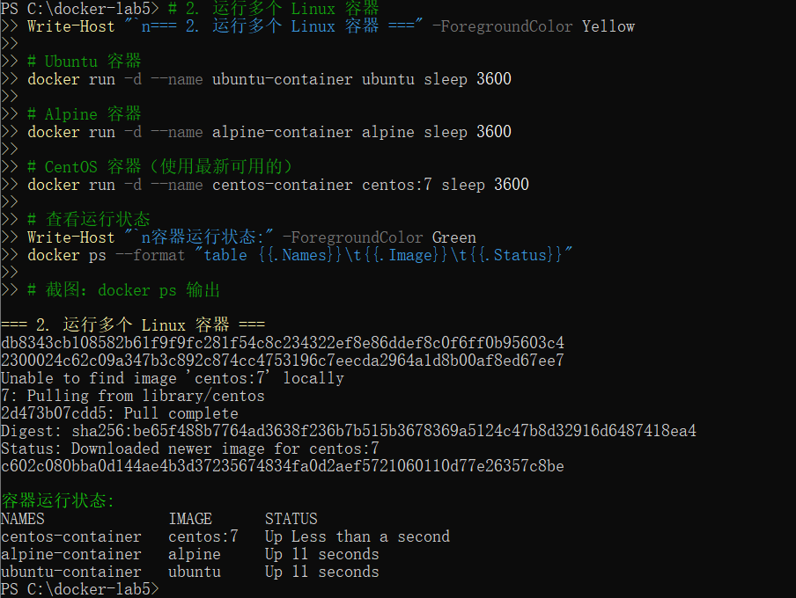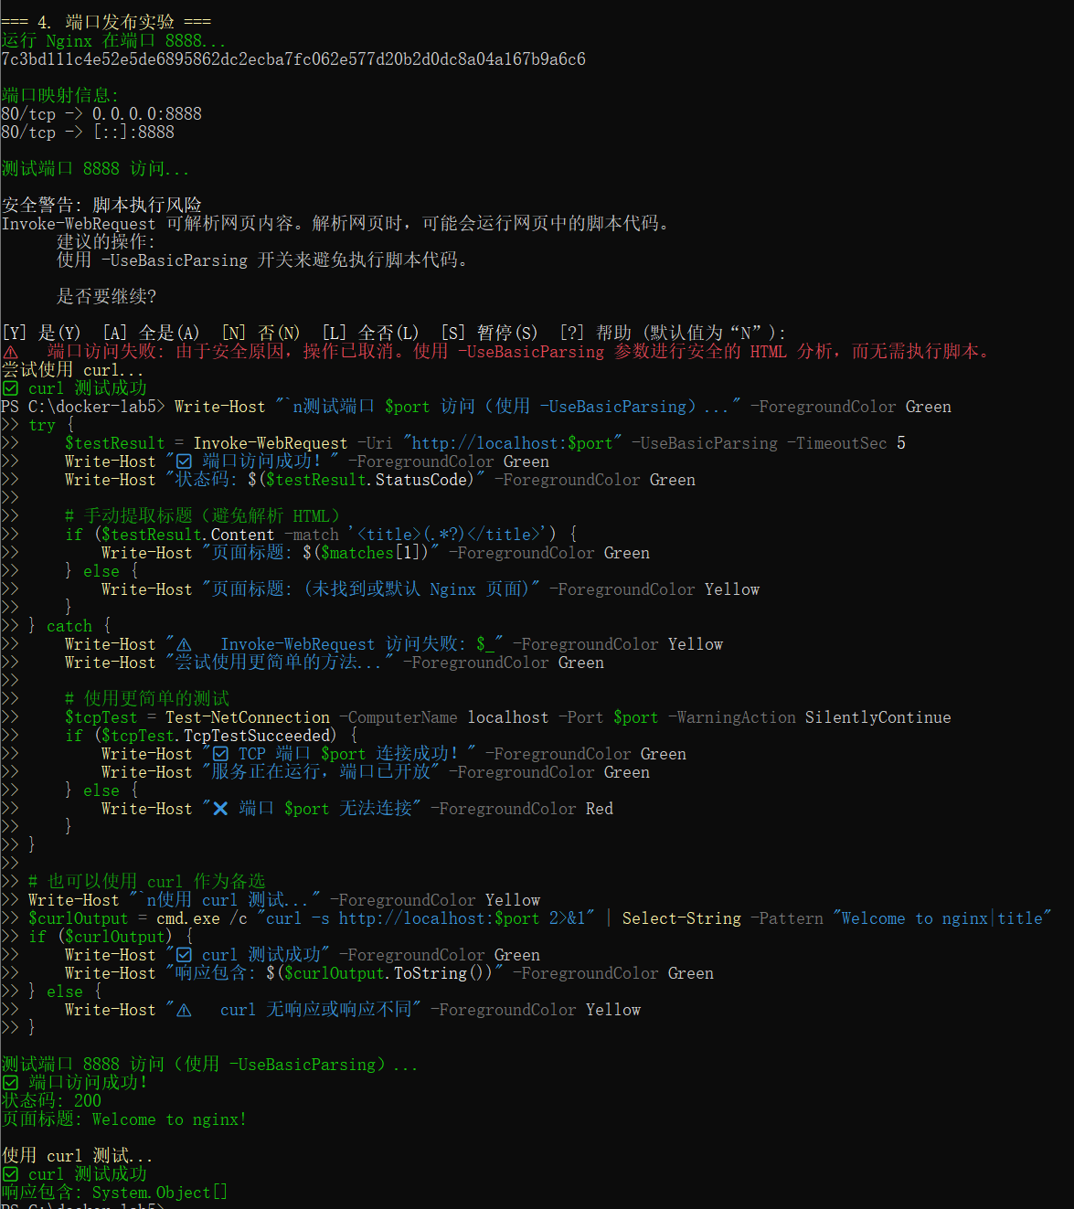Step 3: Test Port Access
curl.exe -s http://localhost:8888 | Select-String "Welcome to nginx" -SimpleMatch

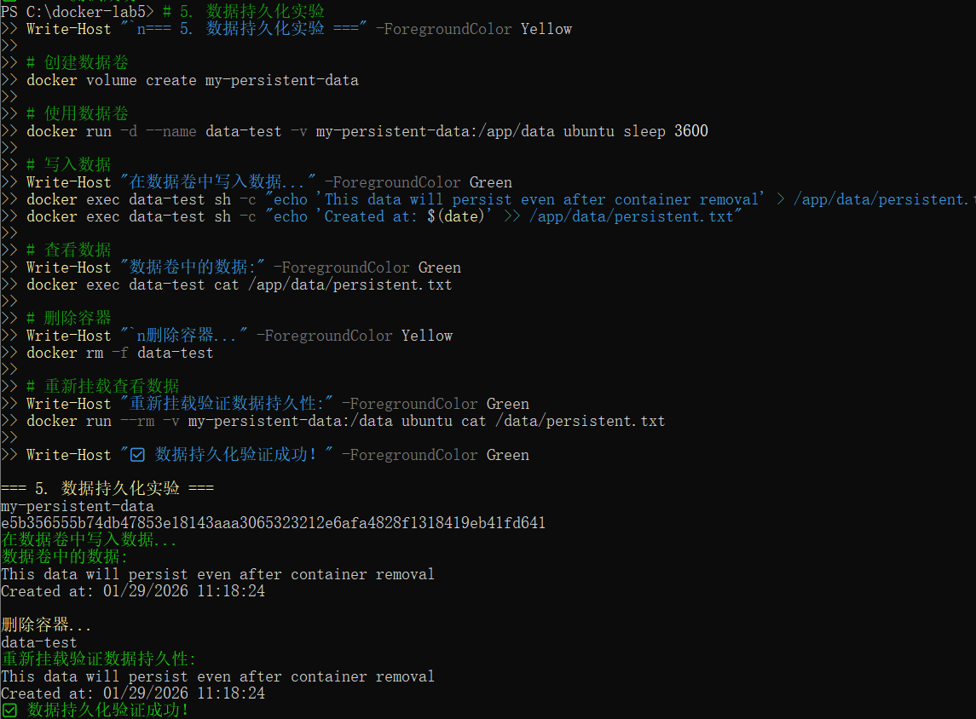Experiment 4: Data Persistence with Volumes

Step 1: Create and Use Docker Volume
docker volume create lab5-volume
docker run -d --name volume-test -v lab5-volume:/data ubuntu sleep 3600
docker exec volume-test sh -c "echo 'Persistent Data Test' > /data/volume-file.txt"
docker exec volume-test cat /data/volume-file.txt

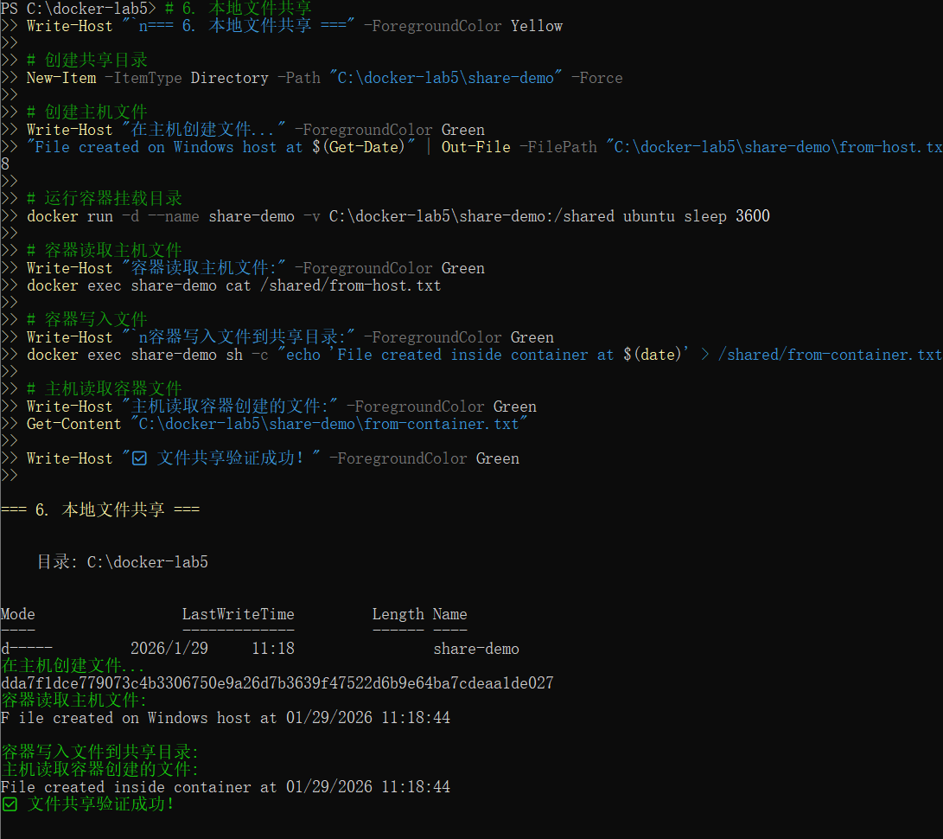Step 2: Test Data Persistence
docker rm -f volume-test
docker run --rm -v lab5-volume:/data ubuntu cat /data/volume-file.txt

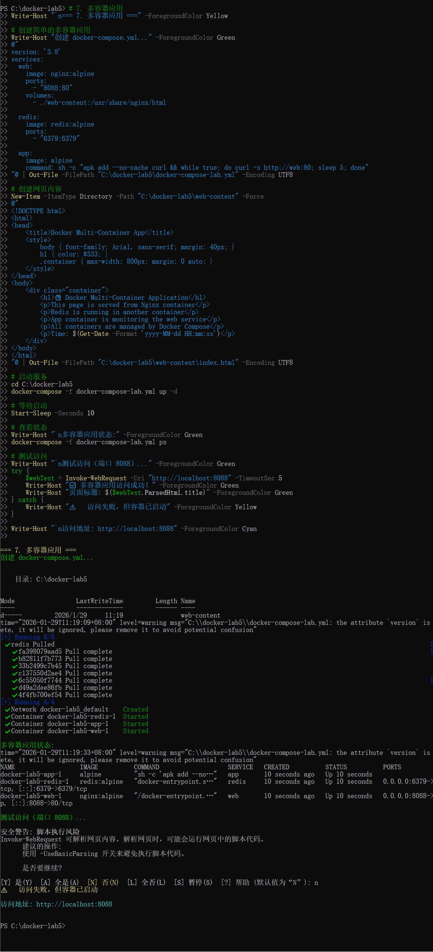

Experiment 5: Local File Sharing

Step 1: Mount Host Directory to Container
mkdir C:\docker-lab5\shared
echo "From Windows Host" > C:\docker-lab5\shared\host-file.txt
docker run -d --name share-test -v C:\docker-lab5\shared:/shared ubuntu sleep 3600

Step 2: Test File Sharing
docker exec share-test cat /shared/host-file.txt
docker exec share-test sh -c "echo 'From Container' > /shared/container-file.txt"
type C:\docker-lab5\shared\container-file.txt

Experiment 6: Multi-Container Applications

Step 1: Create docker-compose.yml
version: '3.8' services: web: image: nginx:alpine ports: - '8081:80' volumes: - ./html:/usr/share/nginx/html db: image: mysql:8.0 environment: MYSQL_ROOT_PASSWORD: root123 MYSQL_DATABASE: testdb ports: - '3306:3306' admin: image: phpmyadmin/phpmyadmin ports: - '8082:80' environment: PMA_HOST: db MYSQL_ROOT_PASSWORD: root123

Step 2: Start Multi-Container Application
mkdir html
echo "

Docker Lab 5
" > html\index.html
docker-compose up -d
docker-compose ps

Experiment 7: Final Verification

Step 1: Verify All Components
docker ps -a --format "table {{.Names}}\t{{.Image}}\t{{.Status}}\t{{.Ports}}"
docker images --format "table {{.Repository}}\t{{.Tag}}\t{{.Size}}"
docker volume ls
docker network ls

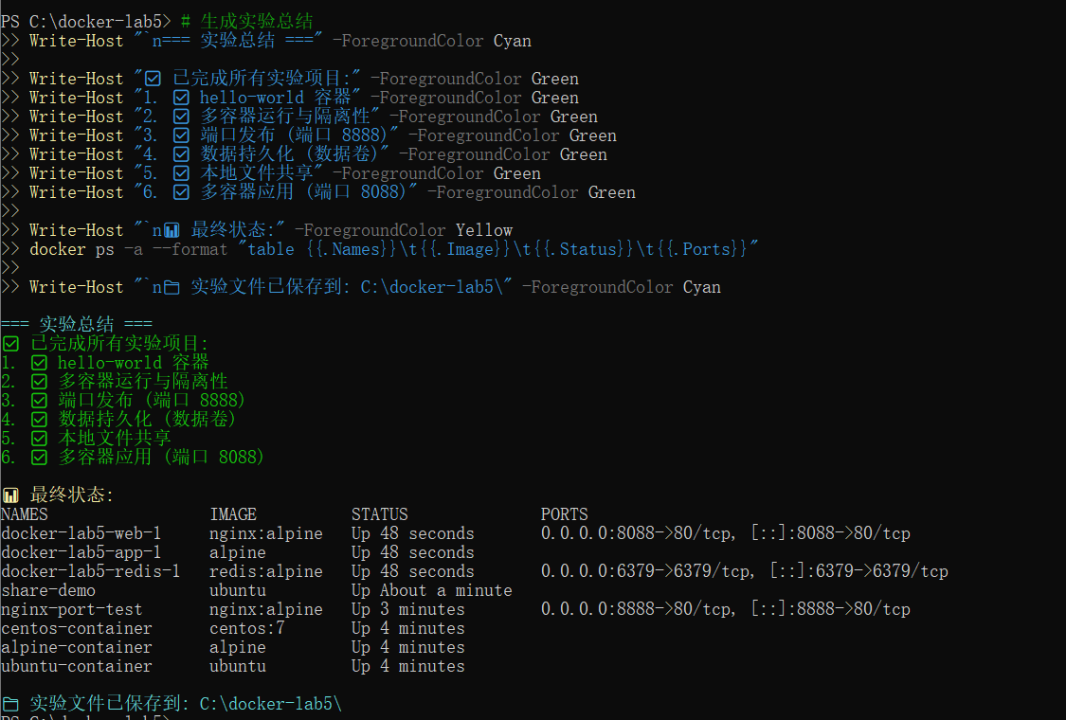✅ All 7 Experiments Completed Successfully

Key Concepts Demonstrated:
1. Container Basics
2. Container Isolation
3. Port Publishing
4. Data Persistence
5. File Sharing
6. Multi-Container Apps
7. Resource Management
